**Developing a Flight Delay Prediction Model using Machine**

**Learning**

TEAM LEADER : Ghaja lakshmi.M

TEAM MEMBER :

1. Firdous.R
2. Kaviya.K
3. Akshaya.A

**Prior Knowledge:**

**Supervised and unsupervised learning:**

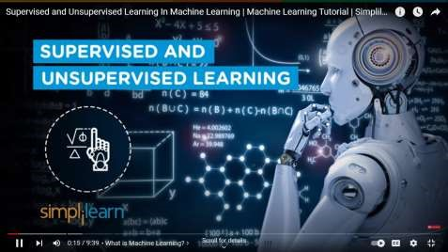

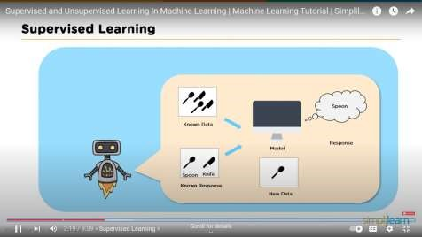

**Regression Classification and Clustering:**

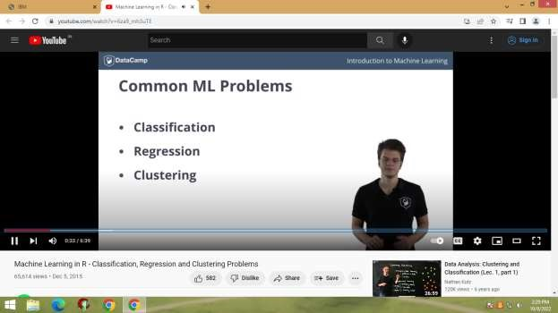

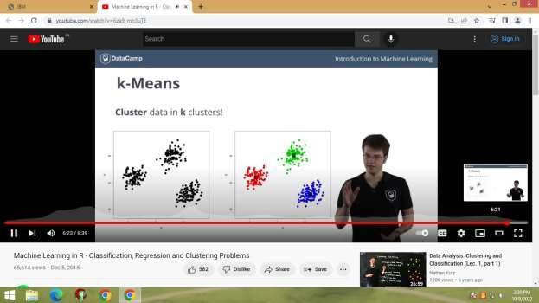

**Flask:**

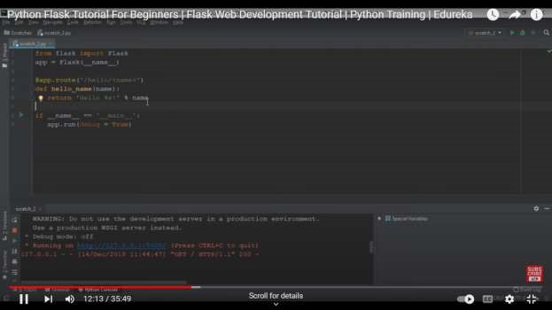

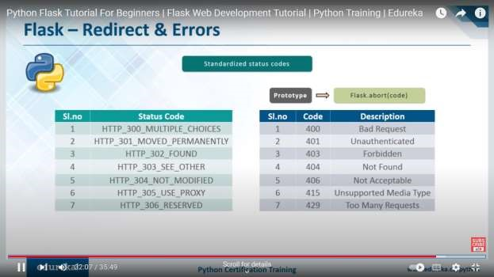

**Decision Tree:**

Entropy in Decision Tree Intuition:

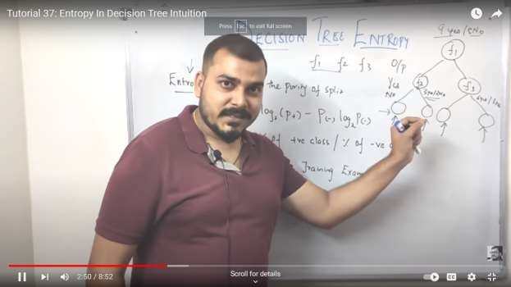

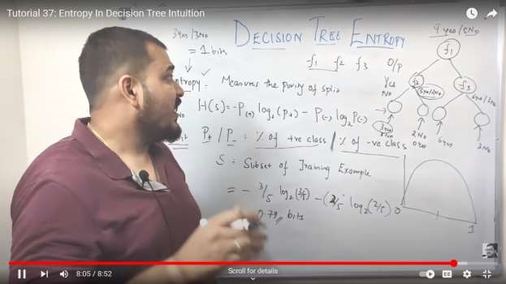

Decision Tree information gain:

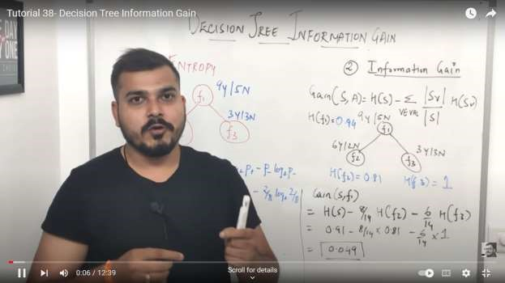

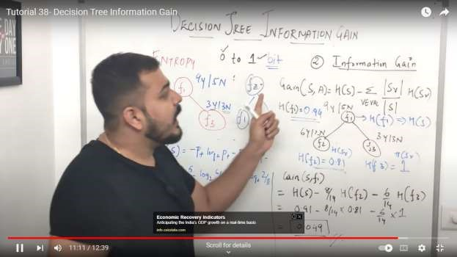

Gini Impurity intuition in depth in Decision Tree:

